- EXCEPTION HANDLING IN C++
- C++ uses a special language-supported exception handling feature to signal such anomalous events. The exception mechanism uses three new keywords:
  - try
  - catch
  - throw

- The function in which error is expected is kept inside
the try block. Exception is thrown from the try block.

This is handled by the catch block immediately following the try block.

- When an exception is thrown, it is caught by the corresponding catch statement, which processes the exception.

- There can be more than one catch statement associated with a try.

- Which catch statement is used is determined by the type of the exception.

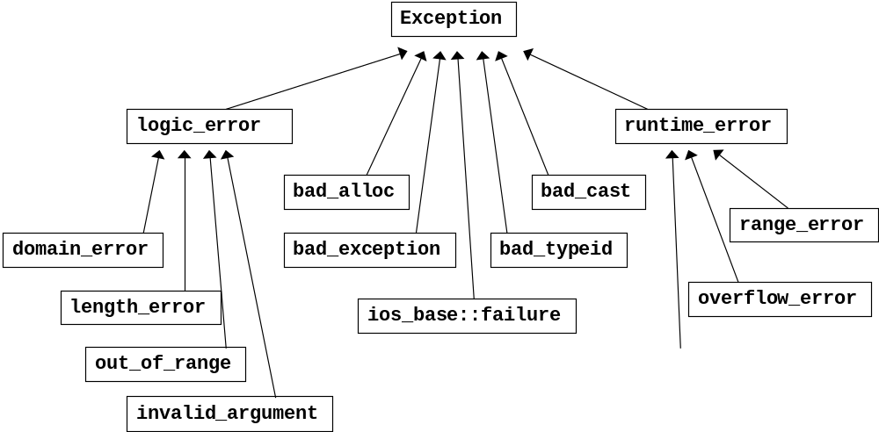

The C++ language provides built-in support for handling anomalous situations, known as “exceptions,” which may occur during the execution of your program. With C++ exception handling, your program can communicate unexpected events to a higher execution context that is better able to recover from such abnormal events. These exceptions are handled by code that is outside the normal flow of control.

In C++, the process of raising an exception is called “throwing” an exception. A designated exception handler then “catches” the thrown exception. Program statements that we want to be monitored for exceptions are contained in a try block. C++ uses two classes to represent and encapsulate exceptions.
1. Skeleton classes. These classes have no members, because their names are sufficient to refer to and handle the exceptions.
2. Classes with data members. These classes declare data members that allow them to better describe the exception.
If an exception (i.e. an error) occurs within the try block , it is thrown. The exception is caught using catch and processed.
Format:
try
{
// try block
}
catch ( type1 arg)
{
// catch block
}
The compound-statement after the try clause is the guarded section of code. The throw-expression throws an exception. The compound-statement after the catch clause is the exception handler, and catches the exception thrown by the throw-expression. The exception-declaration statement after the catch clause indicates the type of exception the clause handles. The type can be any valid data type, including a C++ class.

That is, if the data type specified by a catch matches that of the exception, then that catch statement is executed, and all other catch statements are bypassed. When an exception is caught, the argument specified in the catch clause will receive the exception. Any type of data may be caught, including classes that you create. If no exception is thrown, then no catch statement is executed. if a match is found, the catch handler’s code is executed, and control resumes at the point after the catch handlers.
Execution proceeds as follows:
Control reaches the try statement by normal sequential execution. The guarded section (within the try block) is executed. If no exception is thrown during execution of the guarded section, the catch clauses that follow the try block are not executed. Execution continues at the statement after the last catch clause following the try block in which the exception was expected. If an exception is thrown during execution of the guarded section, or in any routine, the guarded section calls (either directly or indirectly), an exception object is created from the object created by the throw operand. (This implies that a copy constructor may be involved.) At this point, the compiler looks for a catch clause in a higher exception context that can handle an exception of the type thrown (or a catch handler that can handle any type of exception). The catch handlers are examined in order of their appearance following the try block. If no appropriate handler is found, the next dynamically enclosing try block is examined. This process continues until the outermost enclosing try block is examined. if a matching handler is still not found, or if an exception occurs while unwinding, but before the handler gets control, the predefined run-time function terminate( ) is called.
class a
{
public:
int l;
a(int h) { l=h;}
a(int n, int m){l=m, m=n;}
int f()
{ return l;
}};
class b : public a
{ int l;
public:
b(int x, int y) : a(y)
{
l=x;
}int f()
{ return l;
}};
int main()
{ b obj(5,9);
cout<<obj.a::f();
return 0;
}

exceptions
#include <iostream>
using namespace std;

int main () {
try
{
throw 20;
}
catch (int e)
{
cout << "An exception occurred. Exception Nr. " << e << '\n';
}
return 0;
}

try {
try {
// code here
}
catch (int n) {
throw;
}
}
catch (...) {
cout << "Exception occurred";
}

#include <iostream>
#include <exception>
using namespace std;

class myexception: public exception
{
virtual const char* what() const throw()
{
return "My exception happened";
}
} myex;

int main () {
try
{
throw myex;
}
catch (exception& e)
{
cout << e.what() << '\n';
}
return 0;
}

// bad_alloc standard exception
#include <iostream>
#include <exception>
using namespace std;

int main () {
try
{
int* myarray= new int[1000];
}
catch (exception& e)
{
cout << "Standard exception: " << e.what() << endl;
}
return 0;
}

#include<iostream>
#include <string>
using namespace std;

int main ()
{
int num;
string str_bad = "wrong number used";
cout << "Input 1 or 2: ";
cin >> num;

try
{
if ( num == 1 )
{
throw 5;
}
if ( num == 2 )
{
throw 1.1f;
}
if ( num != 1 || num != 2 )
{
throw str_bad;
}
}

catch (int a)
{
cout << "An exception occurred!" << endl;
cout << "Exception number is: " << a << endl;
}
catch (float b)
{
cout << "An exception occurred!" << endl;
cout << "Exception number is: " << b << endl;
}
catch (...)
{
cout << "A default exception occurred!" << endl;
cout << "Why? : " << str_bad << endl;
}
return 0;
}

